Case # | Input | Expected Output | Actual Output
1 | 1 | Show list of PopChange.csv columns | Displayed list of PopChange.csv columns
2 | 1, 1 | Display graph and data of Pop Apr1 | Display graph and data of Pop Apr1
3 | 1,2 | Display graph and data of Pop Jul1 | Displayed graph and data of Pop Jul1
4 | 1,3 | Display graph and data of Change Pop | Displayed graph and data of Change Pop
5 | 1,4 | Display file list | Display File List
6 | 2 | Display list of Housing.csv columns | Displayed list of Housing.csv columns
7 | 2,1 | Display graph and data of Age | Display graph and data of Age
8 | 2, 11 | Display Error retry message | Displayed Error retry message
9 | 2,a | Display Error retry message | Displayed Error retry message
10 | 3 | Display exit message | Displayed exit message

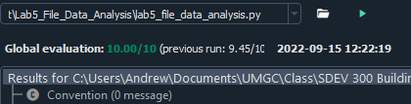

TC1:
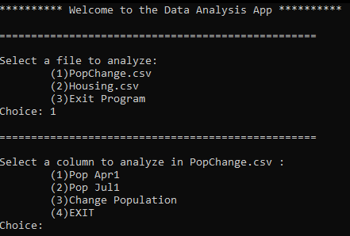

TC2:
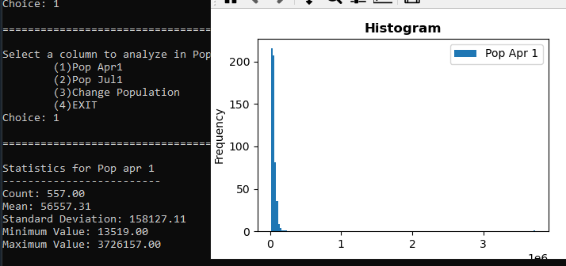

TC3:
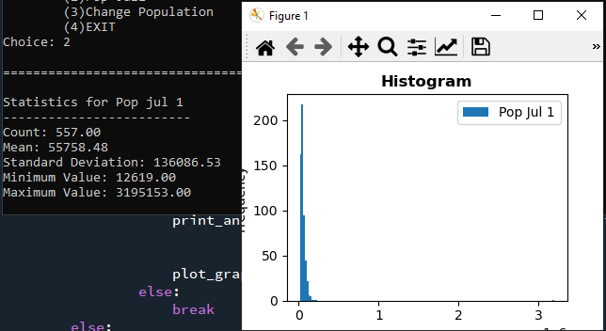

TC4:
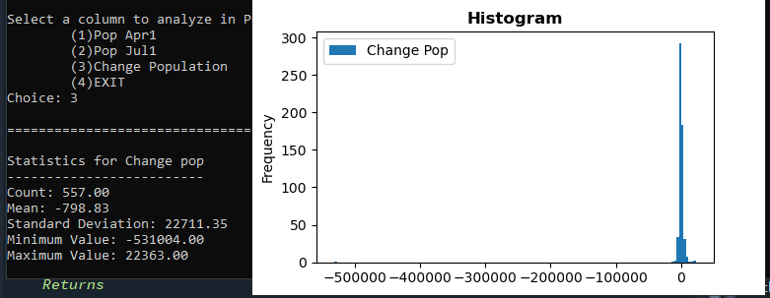

TC5:
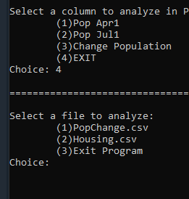

TC6:
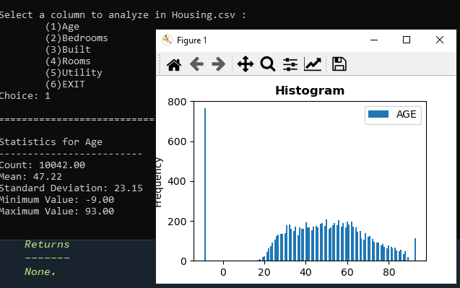

TC7:
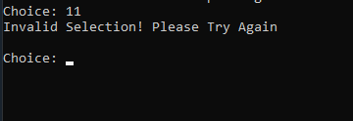

TC8:
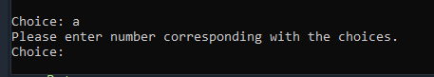
TC9:

